

S.B. JAIN INSTITUTE OF TECHNOLOGY MANAGEMENT & RESEARCH, NAGPUR

Practical 07

Aim: Develop a program to manage resource allocation for five processes (Google Drive, Firefox, Word Processor, Excel, and PowerPoint) using four types of resources (Printer, ROM, Hard Disk, and RAM). The program takes input for allocated, maximum, and available resources, calculates the current need of each process, and determines if a safe execution order exists using the Banker's Algorithm.

Name: Aakshay Dhoke
USN: CM25D001
Semester / Year: Academic Session: Date of Performance: Date of Submission:

- Aim: Develop a program to manage resource allocation for five processes (Google Drive, Firefox, Word Processor, Excel, and PowerPoint) using four types of resources (Printer, ROM, Hard Disk, and RAM). The program takes input for allocated, maximum, and available resources, calculates the current need of each process, and determines if a safe execution order exists using the Banker's Algorithm.

Objectives:
  - Implement the Banker's Algorithm to manage resource allocation and prevent deadlocks.
  - Calculate the current resource need for each process based on allocated and maximum resources.
  - Determine a safe execution sequence for processes if resources are available.

Requirements:
- Hardware Requirements:
- Processor: Minimum 1 GHz
- RAM: 512 MB or higher
- Storage: 100 MB free space

Software Requirements:
- Operating System: Linux/Unix-based
- Shell: Bash 4.0 or higher
- Text Editor: Nano, Vim, or any preferred editor

Theory:
Banker’s Algorithm in Operating System
Banker’s Algorithm is a resource allocation and deadlock avoidance algorithm used in operating systems. It ensures that a system remains in a safe state by carefully allocating resources to processes while avoiding unsafe states that could lead to deadlocks.
  - The Banker’s Algorithm is a smart way for computer systems to manage how programs use resources, like memory or CPU time.
  - It helps prevent situations where programs get stuck and can not finish their tasks. This condition is known as deadlock.
  - By keeping track of what resources each program needs and what’s available, the banker algorithm makes sure that programs only get what they need in a safe order.

Why Banker’s Algorithm is Named So?
The banker’s algorithm is named so because it is used in the banking system to check whether a loan can be sanctioned to a person or not. Suppose there are n number of account holders in a bank and the total sum of their money is S. Let us assume that the bank has a certain amount of money Y. If a person applies for a loan then the bank first subtracts the loan amount from the total money that the bank has (Y) and if the remaining amount is greater than S then only the loan is sanctioned. It is done because if all the account holders come to withdraw their money then the bank can easily do it.
It also helps the OS to successfully share the resources between all the processes. The banker’s algorithm uses the notation of a safe allocation state to ensure that granting a resource request cannot lead to a deadlock either immediately or in the future. In other words, the bank would never allocate its money in such a way that it can no longer satisfy the needs of all its customers. The bank would try to be in a safe state always.
Components of the Banker’s Algorithm
The following Data structures are used to implement the Banker’s Algorithm:
Let ‘n’ be the number of processes in the system and ‘m’ be the number of resource types.

Available
  - It is a 1-D array of size ‘m’ indicating the number of available resources of each type.
  - Available[ j ] = k means there are ‘k’ instances of resource type Rj

Max
  - It is a 2-d array of size ‘n*m’ that defines the maximum demand of each process in a system.
  - Max[ i, j ] = k means process Pi may request at most ‘k’ instances of resource type Rj.

Allocation
  - It is a 2-d array of size ‘n*m’ that defines the number of resources of each type currently allocated to each process.
  - Allocation[ i, j ] = k means process Pi is currently allocated ‘k’ instances of resource type Rj

Need
  - It is a 2-d array of size ‘n*m’ that indicates the remaining resource need of each process.
  - Need [ i, j ] = k means process Pi currently needs ‘k’ instances of resource type Rj
  - Need [ i, j ] = Max [ i, j ] – Allocation [ i, j ]
Allocation specifies the resources currently allocated to process Pi and Need specifies the additional resources that process Pi may still request to complete its task.

Banker’s algorithm consists of a Safety algorithm and a Resource request algorithm.
Banker’s Algorithm
- Active := Running U Blocked for k = 1 to r:
New_request[k] := Requested_resources[requesting_process, k]
- Simulated_allocation := Allocated_resources for k = 1 to r: // Compute projected allocation state Simulated_allocation[requesting_process, k] :=
Simulated_allocation[requesting_process, k] + New_request[k]
- Feasible := true
for k = 1 to r: // Check if projected allocation state is feasible if Total_resources[k] < Simulated_total_alloc[k]:
Feasible := false
- if Feasible = true:
while set Active contains a process P1 such that:
for all k, Total_resources[k] – Simulated_total_alloc[k] >= Max_need[P1, k] – Simulated_allocation[P1, k]:
Delete P1 from Active for k = 1 to r:
Simulated_total_alloc[k] :=
Simulated_total_alloc[k] – Simulated_allocation[P1, k]

if set Active is empty:
for k = 1 to r: // Delete the request from pending requests Requested_resources[requesting_process, k] := 0
for k = 1 to r: // Grant the request Allocated_resources[requesting_process, k] := Allocated_resources[requesting_process, k] + New_request[k] Total_alloc[k] := Total_alloc[k] + New_request[k]

Safety Algorithm
The algorithm for finding out whether or not a system is in a safe state can be described as follows:
- Let Work and Finish be vectors of length ‘m’ and ‘n’ respectively. Initialize: Work = Available
Finish[i] = false; for i=1, 2, 3, 4….n
- Find an i such that both
  - Finish[i] = false
  - Needi <= Work
if no such i exists goto step (4)
- Work = Work + Allocation[i]
Finish[i] = true goto step (2)
- if Finish [i] = true for all i then the system is in a safe state.

Resource-Request Algorithm
Let Requesti be the request array for process Pi. Requesti [j] = k means process Pi wants k instances of resource type Rj. When a request for resources is made by process Pi, the following actions are taken:
- If Requesti <= Needi
Goto step (2) ; otherwise, raise an error condition, since the process has exceeded its maximum claim.
- If Requesti <= Available
Goto step (3); otherwise, Pi must wait, since the resources are not available.
- Have the system pretend to have allocated the requested resources to process Pi by modifying the state as
follows:
Available = Available – Requesti Allocationi = Allocationi + Requesti Needi = Needi– Requesti
Example: Considering a system with five processes P0 through P4 and three resources of type A, B, C. Resource type A has 10 instances, B has 5 instances and type C has 7 instances. Suppose at time t0 following snapshot of the system has been taken:

Unsafe State in The Bankers Algorithm
In the context of the Banker’s Algorithm, an unsafe state refers to a situation in which, all processes in a system currently hold resources within their maximum needs, there is no guarantee that the system can avoid a deadlock in the future. This state is contrasted with a safe state, where there exists a sequence of resource allocation and deallocation that guarantees that all processes can complete without leading to a deadlock.
Key Concepts in Banker’s Algorithm
- Safe State: There exists at least one sequence of processes such that each process can obtain the needed resources, complete its execution, release its resources, and thus allow other processes to eventually complete without entering a deadlock.
- Unsafe State: Even though the system can still allocate resources to some processes, there is no guarantee that all processes can finish without potentially causing a deadlock.
Example of Unsafe State
Consider a system with three processes (P1, P2, P3) and 6 instances of a resource. Let’s say:
- The available instances of the resource are: 1
- The current allocation of resources to processes is:
  - P1: 2
  - P2: 3
  - P3: 1
- The maximum demand (maximum resources each process may eventually request) is:
  - P1: 4
  - P2: 5
  - P3: 3
In this situation:

Need = Maximum Demand – Allocation

Process | Maximum Demand | Allocation | Need
P1 | 4 | 2 | 2
P2 | 5 | 3 | 2
P3 | 3 | 1 | 2

- P1 may need 2 more resources to complete.
- P2 may need 2 more resource to complete.
- P3 may need 2 more resources to complete.
However, there is only 1 resource available. Even though none of the processes are currently deadlocked, the system is in an unsafe state because there is no sequence of resource allocation that guarantees all processes can complete.

CODE

#include <stdio.h>

#include <stdbool.h>

#include <string.h>

#define NUM_PROCESSES 5

#define NUM_RESOURCES 4

// Process names

char* process_names[] = {"Google Drive", "Firefox", "Word Processor", "Excel", "PowerPoint"};

// Resource names

char* resource_names[] = {"Printer", "ROM", "Hard Disk", "RAM"};

// Function to calculate need matrix

void calculateNeed(int need[NUM_PROCESSES][NUM_RESOURCES],

int max[NUM_PROCESSES][NUM_RESOURCES],

int alloc[NUM_PROCESSES][NUM_RESOURCES]) {

for(int i = 0; i < NUM_PROCESSES; i++) {

for(int j = 0; j < NUM_RESOURCES; j++) {

need[i][j] = max[i][j] - alloc[i][j];

}

}

}

// Function to check if system is in safe state

bool isSafeState(int available[NUM_RESOURCES],

int max[NUM_PROCESSES][NUM_RESOURCES],

int alloc[NUM_PROCESSES][NUM_RESOURCES],

int need[NUM_PROCESSES][NUM_RESOURCES]) {

int work[NUM_RESOURCES];

bool finish[NUM_PROCESSES];

int safeSequence[NUM_PROCESSES];

int count = 0;

// Initialize work with available resources

for(int i = 0; i < NUM_RESOURCES; i++) {

work[i] = available[i];

}

// Initialize finish array to false

for(int i = 0; i < NUM_PROCESSES; i++) {

finish[i] = false;

}

// Find safe sequence

while(count < NUM_PROCESSES) {

bool found = false;

for(int p = 0; p < NUM_PROCESSES; p++) {

if(finish[p] == false) {

// Check if need <= work for all resources

bool canExecute = true;

for(int j = 0; j < NUM_RESOURCES; j++) {

if(need[p][j] > work[j]) {

canExecute = false;

break;

}

}

if(canExecute) {

// Add allocated resources back to work

for(int j = 0; j < NUM_RESOURCES; j++) {

work[j] += alloc[p][j];

}

safeSequence[count++] = p;

finish[p] = true;

found = true;

printf("Process %s can execute\n", process_names[p]);

}

}

}

if(!found) {

printf("\nNo safe sequence exists!\n");

return false;

}

}

// Print safe sequence

printf("\n*** System is in SAFE STATE ***\n");

printf("Safe Sequence: ");

for(int i = 0; i < NUM_PROCESSES; i++) {

printf("%s", process_names[safeSequence[i]]);

if(i < NUM_PROCESSES - 1) {

printf(" -> ");

}

}

printf("\n");

return true;

}

// Function to display resource allocation table

void displayTable(int alloc[NUM_PROCESSES][NUM_RESOURCES],

int max[NUM_PROCESSES][NUM_RESOURCES],

int need[NUM_PROCESSES][NUM_RESOURCES],

int available[NUM_RESOURCES]) {

printf("\n================================================");

printf("\nRESOURCE ALLOCATION TABLE");

printf("\n================================================\n");

// Print header

printf("%-15s", "Process");

for(int j = 0; j < NUM_RESOURCES; j++) {

printf("%12s", resource_names[j]);

}

printf("\n------------------------------------------------\n");

// Print Allocation

printf("\n%-15s", "ALLOCATION:");

for(int i = 0; i < NUM_PROCESSES; i++) {

if(i == 0) printf("\n%-15s", process_names[i]);

else printf("\n%-15s", "");

for(int j = 0; j < NUM_RESOURCES; j++) {

printf("%12d", alloc[i][j]);

}

}

// Print Maximum

printf("\n\n%-15s", "MAXIMUM:");

for(int i = 0; i < NUM_PROCESSES; i++) {

if(i == 0) printf("\n%-15s", process_names[i]);

else printf("\n%-15s", "");

for(int j = 0; j < NUM_RESOURCES; j++) {

printf("%12d", max[i][j]);

}

}

// Print Need

printf("\n\n%-15s", "NEED:");

for(int i = 0; i < NUM_PROCESSES; i++) {

if(i == 0) printf("\n%-15s", process_names[i]);

else printf("\n%-15s", "");

for(int j = 0; j < NUM_RESOURCES; j++) {

printf("%12d", need[i][j]);

}

}

// Print Available

printf("\n\n%-15s", "AVAILABLE:");

printf("\n%-15s", "");

for(int j = 0; j < NUM_RESOURCES; j++) {

printf("%12d", available[j]);

}

printf("\n================================================\n");

}

// Function to input allocation matrix

void inputAllocation(int alloc[NUM_PROCESSES][NUM_RESOURCES]) {

printf("\nEnter ALLOCATION Matrix:\n");

printf("------------------------\n");

for(int i = 0; i < NUM_PROCESSES; i++) {

printf("For %s:\n", process_names[i]);

for(int j = 0; j < NUM_RESOURCES; j++) {

printf(" %s: ", resource_names[j]);

scanf("%d", &alloc[i][j]);

}

printf("\n");

}

}

// Function to input maximum matrix

void inputMax(int max[NUM_PROCESSES][NUM_RESOURCES]) {

printf("\nEnter MAXIMUM Matrix:\n");

printf("---------------------\n");

for(int i = 0; i < NUM_PROCESSES; i++) {

printf("For %s:\n", process_names[i]);

for(int j = 0; j < NUM_RESOURCES; j++) {

printf(" %s: ", resource_names[j]);

scanf("%d", &max[i][j]);

}

printf("\n");

}

}

// Function to input available resources

void inputAvailable(int available[NUM_RESOURCES]) {

printf("\nEnter AVAILABLE Resources:\n");

printf("-------------------------\n");

for(int j = 0; j < NUM_RESOURCES; j++) {

printf("%s: ", resource_names[j]);

scanf("%d", &available[j]);

}

}

int main() {

int alloc[NUM_PROCESSES][NUM_RESOURCES];

int max[NUM_PROCESSES][NUM_RESOURCES];

int need[NUM_PROCESSES][NUM_RESOURCES];

int available[NUM_RESOURCES];

printf("\n================================================");

printf("\n BANKER'S ALGORITHM IMPLEMENTATION");

printf("\n================================================\n");

// Input data

inputAllocation(alloc);

inputMax(max);

inputAvailable(available);

// Calculate need matrix

calculateNeed(need, max, alloc);

// Display the table

displayTable(alloc, max, need, available);

// Check for safe state

printf("\nChecking for Safe State...\n");

printf("==========================\n");

if(isSafeState(available, max, alloc, need)) {

printf("\n✓ The system can execute all processes safely!\n");

} else {

printf("\n✗ The system is in UNSAFE state!\n");

printf(" Deadlock may occur if all processes request maximum resources.\n");

}

printf("\n================================================\n");

printf("Program completed successfully!\n");

printf("================================================\n");

return 0;

}
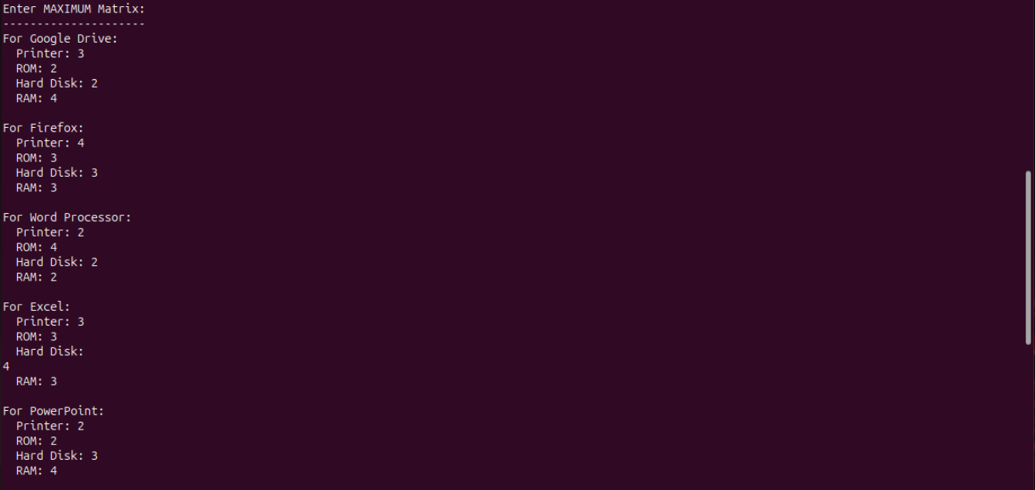
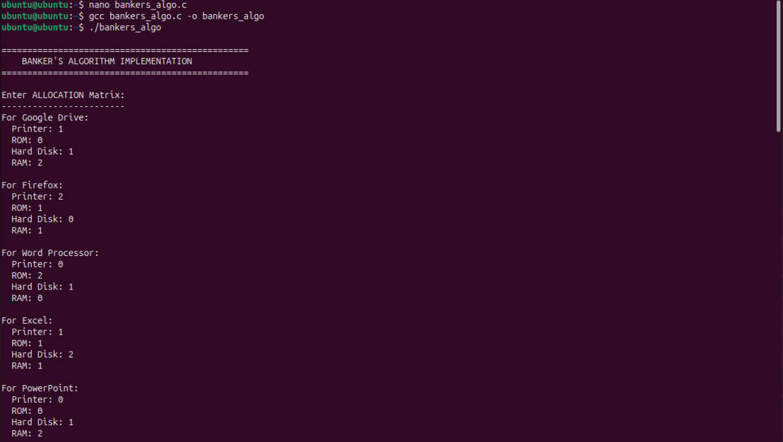
- Output:

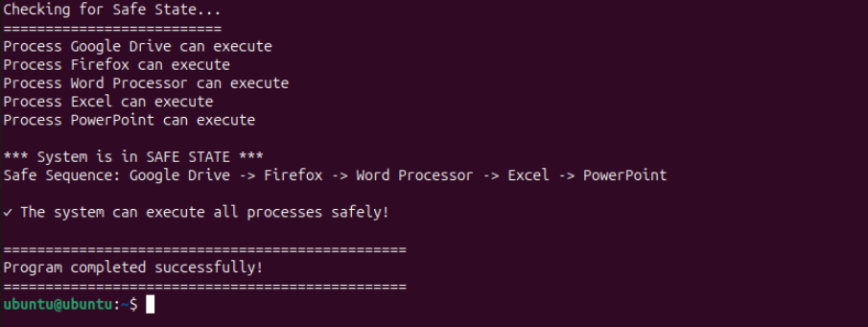
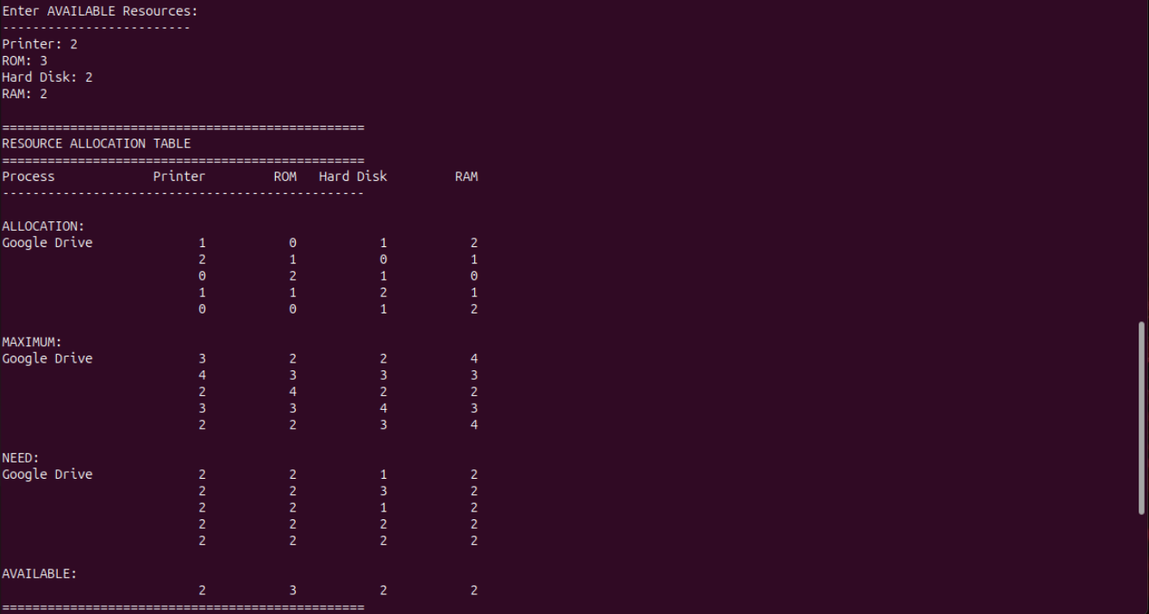
- Conclusion: In this practical, we conclude that the Banker's Algorithm effectively ensures safe resource allocation by preventing deadlocks. By calculating the current resource need of each process and checking for a safe execution sequence, we can determine whether all processes can complete execution without system instability.

Discussion Questions:
- What is the purpose of the Banker's Algorithm?
- How do you calculate the current need of each process?

What are the conditions for a system to be in a safe state?
- What happens if no safe sequence exists in the Banker's Algorithm?
- What are the key inputs required to implement the Banker's Algorithm?

References:
https://www.geeksforgeeks.org/bankers-algorithm-in-operating-system-2/ https://chatgpt.com/

Date: / /2026

Signature Course Coordinator B.Tech CSE(AIML)
Sem: 4 / 2025-26

